PMEducation

MULTI-CRITERIA DECISION ANALYSIS

WHAT IT IS

Multi-Criteria Decision Analysis (MCDA) is a valuable tool for choosing between comparable alternates. It can be used in a group, or alone. It utilizes a decision matrix to provide a systematic analytical approach to: establish key decision criteria, evaluate and rank several alternates, and select the preferred alternate.

In many cases, each alternate has its own Pros and Cons but we can only pick one alternate. For example, a Risk may have several potential Risk Responses, but only one can be selected. “Which one to choose?” The MDCA tool can help answer that question.

HOW IT WORKS

- Establish the parameters. In our example, what is the Risk? What are the potential Risk Responses? Who will be on the Response selection committee?

- Identify the selection criteria that matter for the alternates. For Risk Responses we might look at how the Response affects project Cost, Schedule, Quality, and Team Morale.

- Set up the MCDA table (see below) and assign a relative (importance) weight to each criteria, equaling 100.

- On a scale of 1 to 5, score each Response for each Criterion. Higher score is better than lower score. The scoring can be done individually, or from a questionnaire, or in a group. If scoring is done in a group meeting, allow extra time to reach a consensus.

- For criteria that are numerical, you can use relative ratios to calculate a score out of 5. See Numerical Notes after the figures, below.

- Compute the weighted scores. The arithmetic is:
(Score/5) x Weight = Weighted score
For example ( 4 / 5 ) x 10 = 8

- Look at the overall matrix to see that it looks sensible. Make minor alterations if needed for reasonableness.

- Select highest scored alternate. In our example select Risk Response 3 with 72.5 points.

KEY ELEMENTS

For this method to be effective, the following key elements must be used:

- Representative and knowledgeable participants, if done in a group
- Agreement in the group about using the MDCA tool for finding the best alternate
- Use as few words as possible to keep the diagram legible
ADVANTAGES and DISADVANTAGES
Of MULTI-CRITERIA DECISION ANALYSIS

ADVANTAGES

- Highly visual. Easy to see and to explain to others
- Simple and easy to learn
- No special skills nor software required
- Provides vehicle for Stakeholder Engagement
- Generates discussion amongst participants
- Gives solution where one is not obvious
- Useful any time a decision is needed to choose between comparable alternates

DISADVANTAGES

- Weighting and Scoring are usually subjective
- Requires consensus on the Weights and Scores

FINAL NOTE: This tool is useful for choosing between comparable alternates when you are working on these Project Management processes:

- SCOPE: Collect Requirements and Define Scope
- QUALITY: Plan Quality Management and Perform Quality Assurance
- HUMAN RESOURCES: Acquire Project Team
- RISK: Plan Risk Responses

Below you will find a (weighted) Decision Matrix with 3 alternates to choose from. Response 3 has the most points so would be chosen.
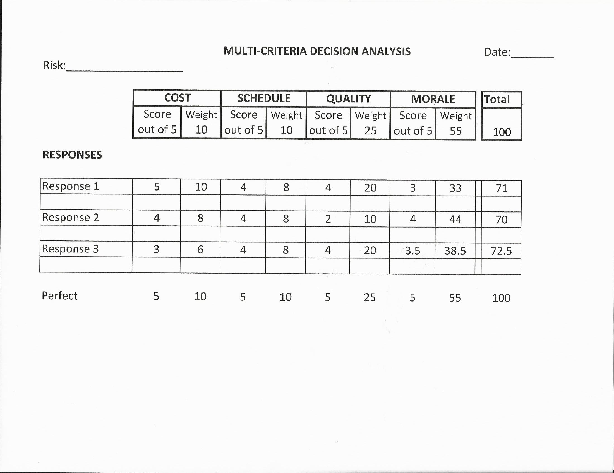

As an interesting comparason, the matrix below is not weighted. You can see a different response would be chosen which would not account for the relative importance of the criteria.

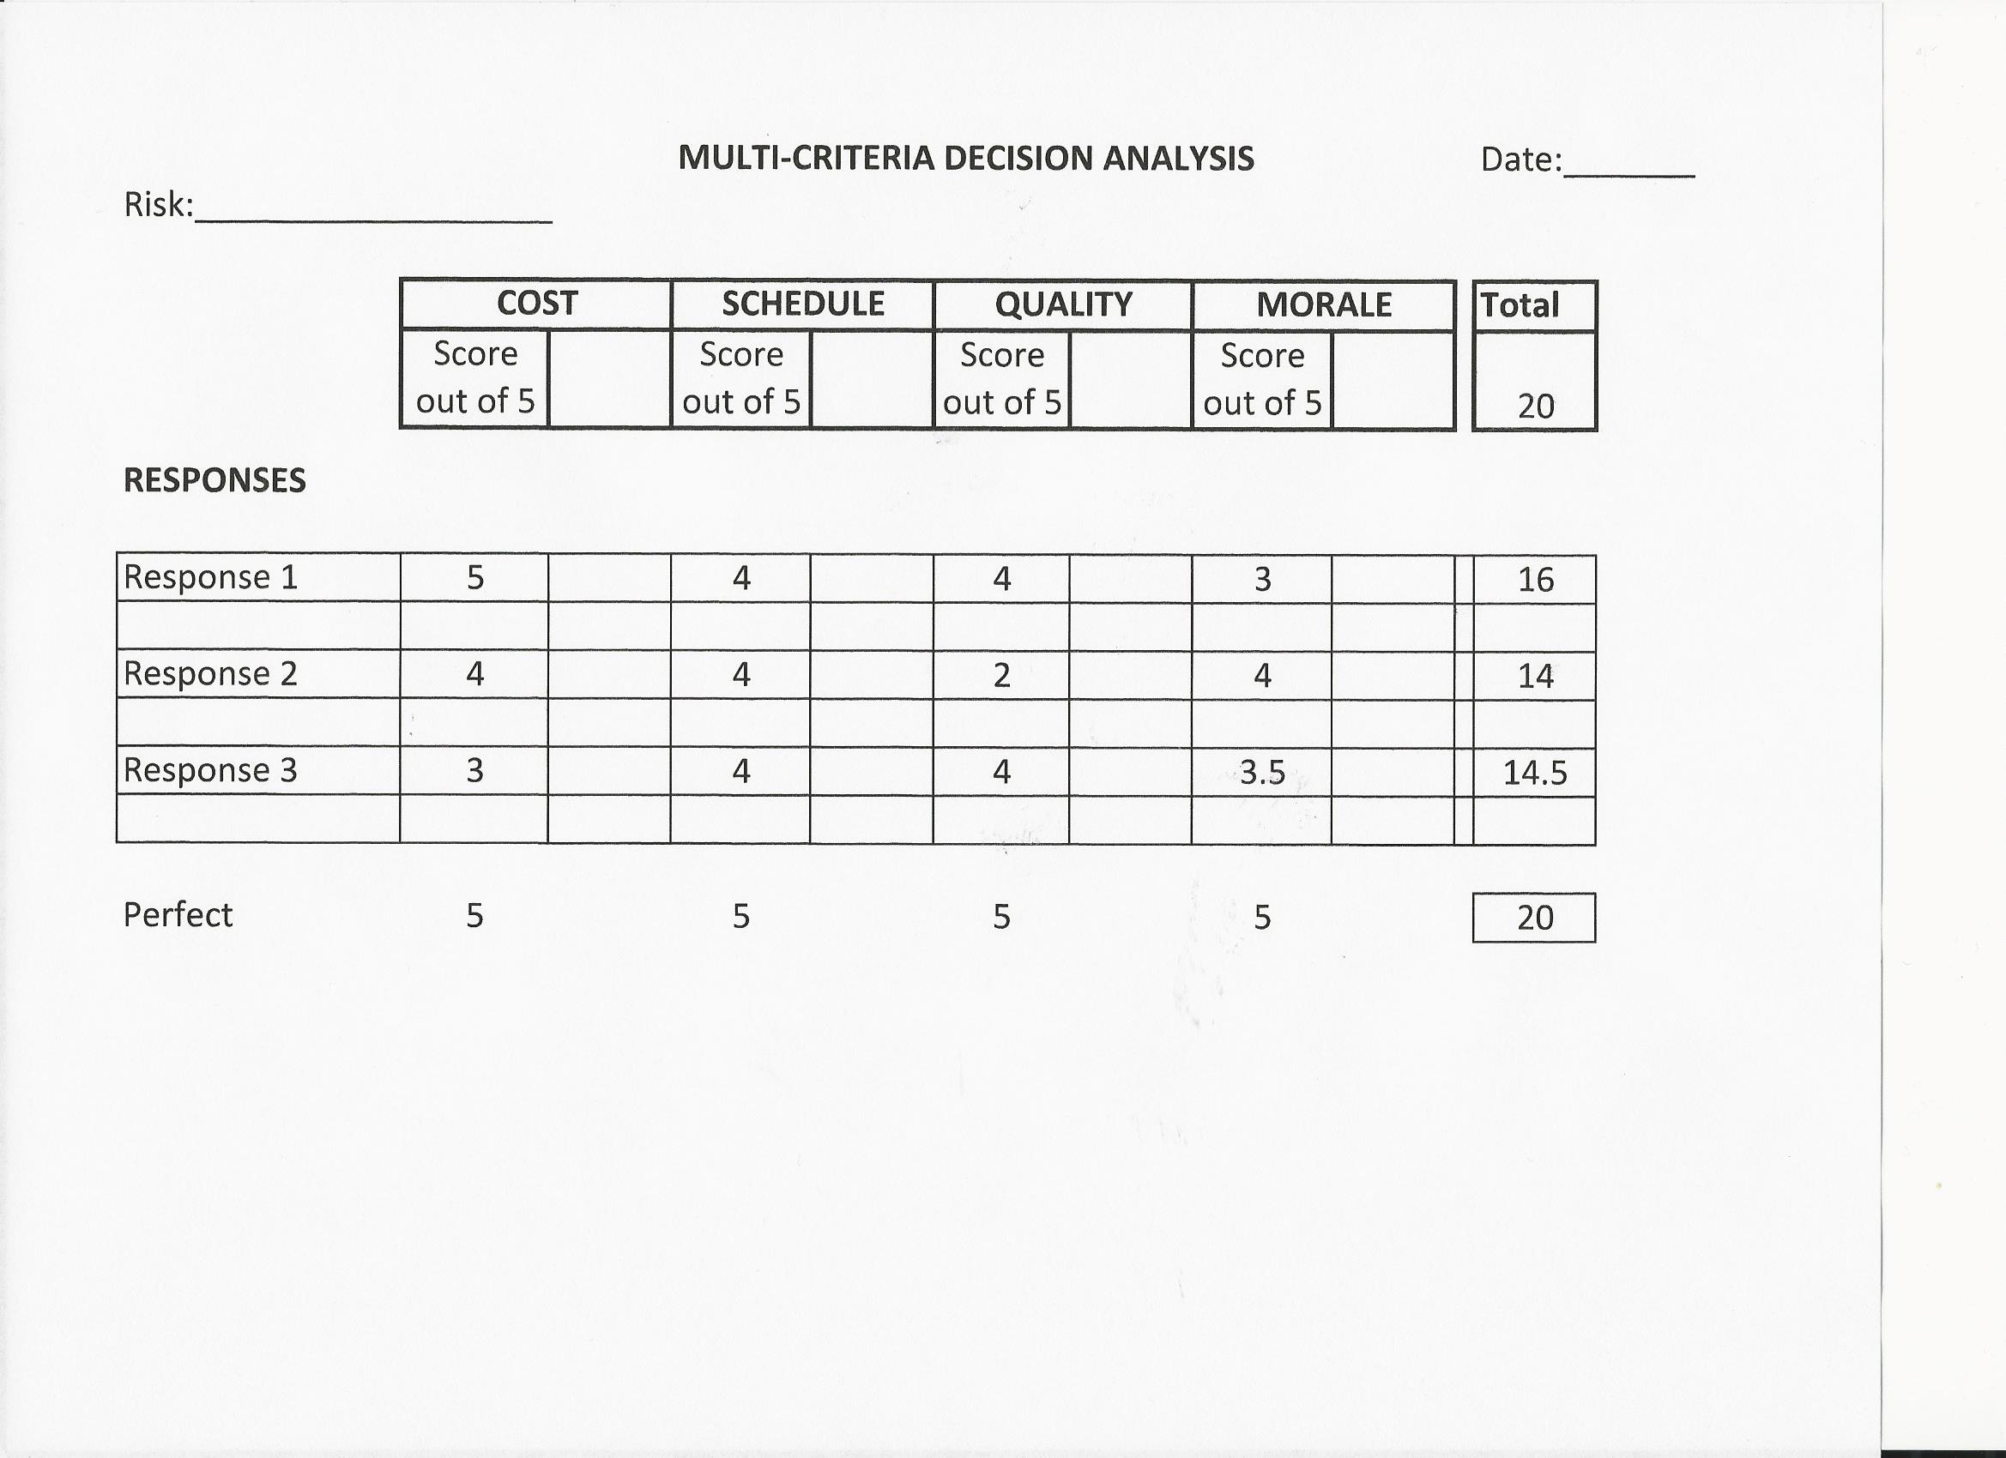

NUMERICAL NOTES

For criteria that are numerical, you can use relative ratios to calculate a score out of 5. For example, for the criterion of cost, take the lowest cost as 5 out of 5. The Cost score of every other Response is found by dividing the cost of each Response into the lowest cost, then multiplying by 5.

Example:

- Lowest cost is $1000. Low cost is desirable.
Other Response Costs are $1200 and $1500.
- Score for $1000 is 5 out of 5.
- Score for $1200 is (1000/1200) x 5 = 4 out of 5.
- Score for $1500 is (1000/1500) x 5 = 3 out of 5.

