PMEducation

PROBABILITY DISTRIBUTION

WHAT IT IS

In Risk Management we recognize that there is a probability of a Risk happening (or not happening) which would affect the project goals. Let us use ‘Time’ in this discussion.

Suppose we say the accuracy of our project Time estimate is plus or minus 20%. We mean the project duration on 100 days could be anywhere from 80 days to 120 days. But what is the probability it will be 120 days? What is the probability it will be 80 days or any other number? How do we address the Risk of a late completion?

To answer those questions we need to know the distribution of the probability over the range of possible completion dates. The range of possible completion dates can be represented on a graph called a Probability Distribution Curve. Typically the probability is on the vertical axis and the outcome (Time or Time Variance in our case) is on the horizontal axis of the curve.

Typical curve shapes include: triangular, normal, lognormal, beta, uniform and discrete. Determining the exact shape of the distribution curve requires statistical expertise beyond the mandate of the Professional Project Manager. However, two probability distribution curves are in common use, the Beta Distribution and the Triangular Distribution.
The Beta Distribution is representative of phenomena that occur in nature, and is preferred when we have a lot of historical data. It is useful for representing distributions that are bound on both sides, like probabilities. Beta Distribution is useful for similar types of projects, and when experts are providing information based on historical evidence & experience.

If we are doing a project for the first time, and there is no previous history of similar projects to fall back on, it makes more sense to use the Triangular Distribution, as there is no basis to give more weight to a particular estimate value. Thus, a Triangular Distribution is more suited for judgmental data estimates, which are not based on a lot of experience or expertise.

The Probability Distribution Curve is a necessary input to Simulation Modelling.

Below you will find the Probability Distribution Curves for Beta Distribution and for Triangular Distribution.

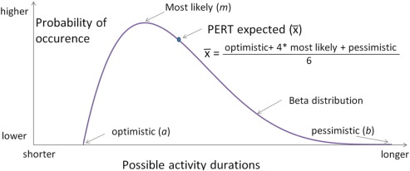

BETA DISTRIBUTION CURVE

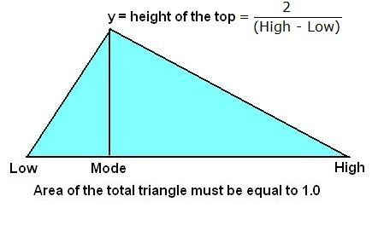
Probability of occurrence
higher
lower

shorter Possible activity durations longer

The Low, Mode, and High values are: optimistic, most likely, and pessimistic, respectively.
_
Three Point Estimate: X = optimistic + most likely + pessimistic
3

TRIANGULAR DISTRIBUTION CURVE

