Guidelines for Conducting a Focus Group

Surveys assume that people know how they feel. But sometimes they really don’t. Sometimes it takes listening to the opinions of others in a small and safe group setting before they form thoughts and opinions. Focus groups are well suited for those situations.

Focus groups can reveal a wealth of detailed information and deep insight. When well executed, a focus group creates an accepting environment that puts participants at ease allowing then to thoughtfully answer questions in their own words and add meaning to their answers. Surveys are good for collecting information about people’s attributes and attitudes but if you need to understand things at a deeper level then use a focus group.

If you’ve ever participated in a well-run focus group you’d probably say it felt very natural and comfortable to be talking with a group of strangers. What you didn’t know perhaps were the many hidden structures behind it all. A good focus group requires planning – a lot more planning than merely inviting a few key people to casually share their opinions about a topic.

Outlined here are the details for conducting a high quality focus group. Also included are step- by-step instructions for making sense of all the information you collect in the groups.

In this Guide you will find checklists for:
- Defining a focus group
- Designing focus group questions
- Recruiting and preparing for participants
- Conducting the focus group
- Analyzing the data

You will also find samples of the following items:
- Focus group questions
- Recruitment flyer
- Invitee tracking form
- Introductory remarks
- Sample consent from
- Data analysis format
- Synthesized report format

Defining a focus group

A focus group is a small group of six to ten people led through an open discussion by a skilled moderator. The group needs to be large enough to generate rich discussion but not so large that some participants are left out.

The focus group moderator nurtures disclosure in an open and spontaneous format. The moderator’s goal is to generate a maximum number of different ideas and opinions from as many different people in the time allotted.

The ideal amount of time to set aside for a focus group is anywhere from 45 to 90 minutes. Beyond that most groups are not productive and it becomes an imposition on participant time.

Focus groups are structured around a set of carefully predetermined questions – usually no more than 10 – but the discussion is free-flowing. Ideally, participant comments will stimulate and influence the thinking and sharing of others. Some people even find themselves changing their thoughts and opinions during the group.

A homogeneous group of strangers comprise the focus group. Homogeneity levels the playing field and reduces inhibitions among people who will probably never see each other again.

It takes more than one focus group on any one topic to produce valid results – usually three or four. You’ll know you’ve conducted enough groups (with the same set of questions) when you’re not hearing anything new anymore, i.e. you’ve reached a point of saturation.

A focus group is not:
- A debate
- Group therapy
- A conflict resolution session
- A problem solving session
- An opportunity to collaborate
- A promotional opportunity
- An educational session

Designing focus group questions
Twelve is the maximum number of questions for any one group.
Ten is better, and eight is ideal.

Focus group participants won’t have a chance to see the questions
they are being asked.

So, to make sure they understand and can fully respond to the questions posed, questions should be:
- Short and to the point
- Focused on one dimension each
- Unambiguously worded
- Open-ended or sentence completion types
- Non-threatening or embarrassing
- Worded in a way that they cannot be answered with a simple “yes” or “no” answer (use “why” and “how” instead)

There are three types of focus group questions:

- Engagement questions: introduce participants to and make them comfortable with the topic of discussion
- Exploration questions: get to the meat of the discussion
- Exit question: check to see if anything was missed in the discussion
AN EXAMPLE
Questions for a Focus Group on Dental Flossing
Engagement questions:
- What is your favorite toothpaste?
- What do you notice when you look at other people’s teeth?
Exploration Questions:
- Who in particular has influenced your dental habits?
- What are the pros and cons of flossing your teeth?
- When you floss, how do follow through? When you don’t, why not?
- How do you feel when told about possible damage caused by not flossing?
- How do you feel about yourself when you floss regularly? When you don’t?
Exit question:
- Is there anything else you would like to say about why you do or do not floss your teeth on a regular basis?
Note: Flossers and non-flossers in separate groups.

Recruiting and preparing for participants

In an ideal focus group, all the participants are very comfortable with each other but none of them know each other.

Homogeneity is key to maximizing disclosure among focus group participants. Consider the following in establishing selection criteria for individual groups:

- Gender – Will both men and women feel comfortable discussing the topic in a mixed gender group?

- Age – How intimidating would it be for a young person to be included in a group of older adults? Or vice versa?

- Power – Would a teacher be likely to make candid remarks in a group where his/her principal is also a participant?

- Cliques – How influential might three cheerleaders be in a group of high school peers?

Participant inclusion/exclusion criteria should be established up- front and based on the purpose of the study. Use the criteria as a basis to screen all potential applicants.

Focus groups participants can be recruited in any one of a number of ways. Some of the most popular include:
- Nomination – Key individuals nominate people they think would make good participants. Nominees are familiar with the topic, known for their ability to respectfully share their opinions, and willing to volunteer about 2 hours of their time.
- Random selection – If participants will come from a large but defined group (e.g. an entire high school) with many eager participants, names can be randomly drawn from a hat until the desired number of verified participants is achieved.
- All members of the same group – Sometimes an already existing group serves as an ideal pool from which to invite participants (e.g. Kiwanis Club, PTO, Chamber of Commerce).
- Same role/job title – Depending on the topic, the pool might be defined by position, title or condition (e.g. , young MBA’s, old writers, community health nurses, parents of teen-age boys).
- Volunteers – When selection criteria is broad, participants can be recruited with flyers and newspaper ads.
Once a group of viable recruits has been established, call each one to confirm interest and availability. Give them times and locations of the focus groups and secure verbal confirmation. Tell them you will mail (or email) them a written confirmation and call to remind them two days before the scheduled group.

AN EXAMPLE
Focus Group Confirmation Letter
November 20, 2017 Dear ________________,

Thank you for your willingness to participate in our focus group. As discussed on the phone, we would like to hear your ideas and opinions about project xyz in Northeast City. You will be in a group with 6 to 9 other parents/guardians of middle and high school students. Your responses to the questions will be kept anonymous. A $65 honorarium will be paid at the end of the focus group discussion. The date, time, and place are listed below. Please look for signs once you arrive directing you to the room where the focus group will be held.
DATE
TIME
PLACE
If you need directions to the focus group or will not be able to attend for any reason please call xxxxxxx xxxxxx at xxx-xxx-xxxx. Otherwise we look forward to seeing you.
Sincerely,
Members of Northeast City Partnership on Project xyz

- Over-invite in anticipation of a no-show rate of 10 to 20 percent.
- But you will not want a group of more than about 10 participants.

- Offer an incentive. In 2016 dollars, a monetary incentive of $50 per participant is probably the minimum you should consider. Other incentive ideas include coupons, gift certificates, paid time off to attend the group, or an opportunity to win a big-ticket item at a drawing conducted at the focus group.

Devise a form to track invitation phone calls. Include an “Address” box for mailing the confirmation letter and a “Comments” box.

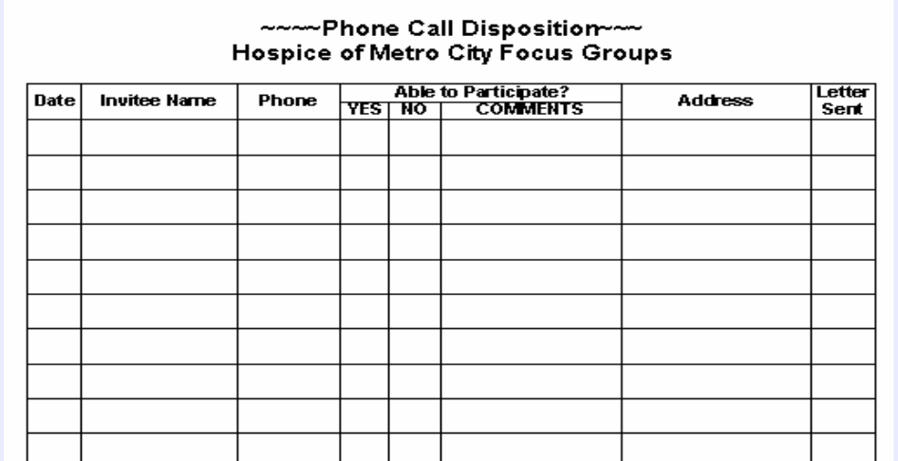
An example

Organize the times, locations and people involved for all the groups you have scheduled.

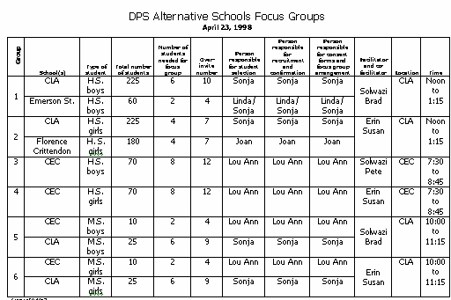
An example:

Reduce barriers to attending when possible by offering:
- Evening or weekend groups for those who work during the day
- Transportation or cab fare
- Child care services
- Interpreter services
- A familiar public setting

Tell participants that the focus group will take about one and half to two hours. Give them a starting time that is 15 minutes prior to the actual start of the focus group to allow for filling out necessary paperwork, having a bite to eat, and settling in to the group.

Arrange for a comfortable room in a convenient location with ample parking. Depending on your group, you may also what to consider proximity to a bus line. The room should have a door for privacy and table and chairs to seat a circle of up to 12 people (10 participants and the moderator and assistant moderator). Many public agencies (churches, libraries) have free rooms available.

Arrange for food. At a minimum, offer a beverage and light snack (cookies, cheese/crackers, veggie tray, etc.). It is OK to offer a full meal but be sure to add an additional 30 to 45 minutes to the entire process so that everyone can finish eating before the group begins.

Conducting the focus group

Ideally, the focus group is conducted by a team consisting of a moderator and assistant moderator. The moderator facilitates the discussion; the assistant takes notes and runs the AV equipment.

The ideal focus group moderator has the following traits:
- Can listen attentively with sensitivity and empathy
- Is able to listen and think at the same time
- Believes that all group participants have something to offer no matter what their education, experience, or background
- Has adequate knowledge of the topic
- Can keep personal views and ego out of the facilitation
- Is someone the group can relate to but also give authority to (e.g. a male moderator is most appropriate for a group of all men discussing sexual harassment in the workplace)
- Can appropriately manage challenging group dynamics

The assistant moderator must be able to do the following:
- Run a tape recorder during the session
- Take notes in case the recorder fails or the tape is inaudible
- Note/record body language or other subtle but relevant clues
- Allow the moderator to do all the talking during the group

Both moderator and assistant moderator are expected to welcome participants, offer them food, help them make their name tents, and direct them in completing pre-group paperwork.

Name tents should identify participants with a number written largely for anonymous identification of individuals as they make comments.

At a minimum, all participants should complete a consent form. If the focus group study involves a university partner or is part of a larger research study you may also be required to secure approval from a Human Subjects Committee.
AN EXAMPLE
Consent to Participate in Focus Group
You have been asked to participate in a focus group sponsored by the Women’s Health Section of the Department of Public Health and Environment. The purpose of the group is to try and understand why some women do not gain enough weight during pregnancy. The information learned in the focus groups will be used to design public health messages intended to encourage women to gain adequate weight during pregnancy.

You can choose whether or not to participate in the focus group and stop at any time. Although the focus group will be tape recorded, your responses will remain anonymous and no names will be mentioned in the report.
There are no right or wrong answers to the focus group questions. We want to hear many different viewpoints and would like to hear from everyone. We hope you can be honest even when your responses may not be in agreement with the rest of the group. In respect for each other, we ask that only one individual speak at a time in the group and that responses made by all participants be kept confidential.

I understand this information and agree to participate fully under the conditions stated above:
Signed:____________________________________________ Date:___________________

It may be important to collect demographic information from participants if age, gender, or other attributes are important for correlation with focus group findings. Design a short half page form that requires no more than two or three minutes to complete. Administer it before the focus group begins.

Physician Focus Group Participant Demographics
Date: Time: |  | Place:
What is your | How long have you been |  | How many deliveries do
specialty: | in practice? |  | you average per month?
0 OB/GYN | 0 Less than 5 years |  | 0 Less than 5
0 Family Practice | 0 5 to 10 years |  | 0 6 to 10
0 Other: | 0 more than 10 years |  | 0 more than 10
Type of practice: | Your age: |  | Your gender:
0 Public | 0 30 to 40 |  | 0 Male
0 Private | 0 41 to 50 |  | 0 female
0 HMO | 0 51 to 60
0 Other: | 0 over 60

Once consent forms and demographic surveys are collected and reviewed for completeness, the questioning begins. The moderator uses a prepared script to welcome participants, remind them of the purpose of the group and also sets ground rules.
AN EXAMPLE

FOCUS GROUP INTRODUCTION
WELCOME
Thanks for agreeing to be part of the focus group. We appreciate your willingness to participate.
INTRODUCTIONS
Moderator; assistant moderator
PURPOSE OF FOCUS GROUPS
We have been asked by _________________to conduct the focus groups. The reason we are having these focus groups is to find out_______________.
We need your input and want you to share your honest and open thoughts with us.
GROUND RULES
- WE WANT YOU TO DO THE TALKING. We would like everyone to participate.
I may call on you if I haven't heard from you in a while.
- THERE ARE NO RIGHT OR WRONG ANSWERS
Every person's experiences and opinions are important. Speak up whether you agree or disagree.
We want to hear a wide range of opinions.
- WHAT IS SAID IN THIS ROOM STAYS HERE
We want folks to feel comfortable sharing when sensitive issues come up.
- WE WILL BE TAPE RECORDING THE GROUP
We want to capture everything you have to say.
We don't identify anyone by name in our report. You will remain anonymous.

Before asking the first focus group question, an icebreaker can be inserted to increase comfort and level the playing field. Example: “If you had a limitless budget, where would you vacation?”

The focus group moderator has a responsibility to adequately cover all prepared questions within the time allotted. S/he also has a responsibility to get all participants to talk and fully explain their answers. Some helpful probes include:

“Can you talk about that more?”
- “Help me understand what you mean”
- “Can you give an example?”

It is good moderator practice to paraphrase and summarize long, complex or ambiguous comments. It demonstrates active listening and clarifies the comment for everyone in the group.

Because the moderator holds a position of authority and perceived influence, s/he must remain neutral, refraining from nodding/raising eyebrows, agreeing/disagreeing, or praising/denigrating any comment made.

A moderator must tactfully deal with challenging participants.
Here are some appropriate strategies:
- Self-appointed experts: “Thank you. What do other people think?”
- The dominator: “Let’s have some other comments.”
- The rambler: Stop eye contact; look at your watch; jump in at their inhale.
- The shy participant: Make eye contact; call on them; smile at them.
- The participant who talks very quietly: Ask them to repeat their response more loudly.

When the focus group is complete the moderator thanks all participants and distributes the honorarium (incentive).

Immediately after all participants leave, the moderator and assistant moderator debrief while the recorder is still running and label all tapes and notes with the date, time (if more than one group per day), and name of the group.

Analyzing the data
In order for all participant comments to be understandable and useful, they must be boiled down to essential information using a systematic and verifiable process. Begin by transcribing all focus group tapes and inserting notes into transcribed material where appropriate.

Clean up transcripts by stripping off nonessential words.
Simultaneously assign each participant comment/quote a separate line on the page as well as each new thought or idea therein. Label
each line with the participant and group number, e.g. a comment from participant 6 in group 2 would be assigned the number 2.6.

Each line is then entered into an Excel database as follows:
COMPILE 1. Use a separate Excel data base spreadsheet for each group.
  - Within each spreadsheet, use one sheet per question.
  - Label three columns on each sheet.
    - One column for coding
    - One column for the participant ID#
    - One column for responses
  - Enter each separate response or idea on a separate line with participant ID attached. The coding column is filled in during the next phase - analysis.

ANALYZE 1. When all comments have been entered, look for common categories or themes across the entries for each question. The most ideal situation is to ask several people to participate in this process.
- Once consensus has been achieved regarding the best categories for organizing the data, assign a number or letter to each category.
- Then assign the number/letter of the category that best fits to each entry on the sheet.
- Use the Excel ‘Sort’ function to group entries by the categories you have assigned to them.
- If some entries seem inconsistent for their category, consider re-categorizing or adding another category. It may also be apparent that one or more categories can be collapsed.
- Arrange categories from those with the largest number of entries to those with the smallest.
- Repeat for each gro
SYNTHESIZE 1. Identify category and sub-category heading titles.

yright © Eliot & Associates. All rights reserved.
- Write a short paragraph summarizing findings for each sub-category possibly noting similarities and differences across groups.
- Add powerful quotes to each sub-section Analysis of focus group data, an example:
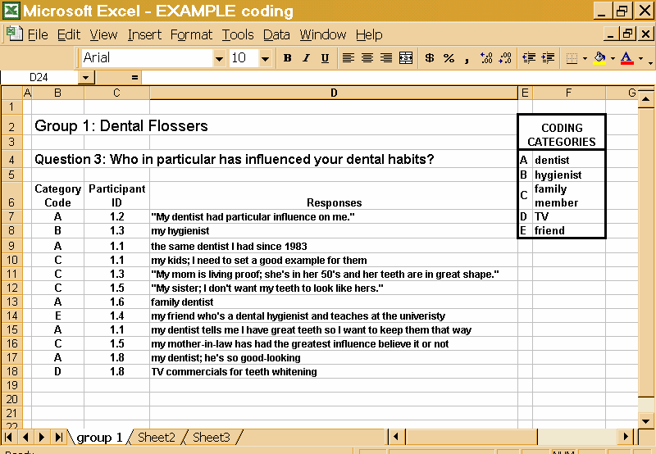

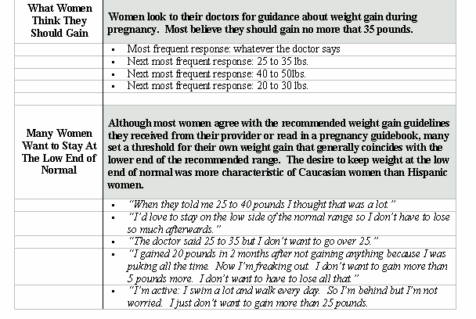
Synthesized focus group data, an example:

As an alternative to the spreadsheet method described here, you can also use a manual approach to analyzing focus group data. Make a copy of the transcript after it has been cleaned and labeled. Working on a large table, cut entries into separate strips and run a glue stick over the back. Categorize by sticking entries onto separate sheets of paper labeled with broad headings. Re-categorize as indicated until you are satisfied with your groupings. Enter into a Word document.

Once focus group findings are organized in the synthesized format they are ready for presentation. If a more formal report is required, findings can be written up in a narrative format that includes an executive summary, background section, methods used, major findings, conclusions, and recommendations.

